**MinusK Passive Isolation Development**

**Matthew del Toro**

***Outline:***

1. Purpose
2. Theory
   1. Background on RMS measurement, Fast Fourier Transform, Acceleration Spectral Density
   2. MinusK Transmissibility and performance specs
      1. Method of evaluation (Measure spectrum input/compare to output)
3. Experimental Setup
   1. Hardware Specifications
   2. Troubleshooting to converge on proper settings
4. Results
5. MinusK Tests
   * 1. Initial Test
        1. MinusK w/ 59 kg
     2. More Detail focus tests
        1. Vertical w/ block
        2. Horizontal w/ block
        3. Precision C.G. Test (include setup)

B. Environments Test

1. Vibrations on the mechanical table
2. Vibrations on the lab table
3. Vibrations on the ground @ site
4. Vibrations in the bluesg car @ site
5. Transmissibility curves for all three (wait for 2nd accel)
6. Evaluation of Results
7. Comparisons
   1. Comparison of mech table input vibrations to MinusK performance
   2. Initial Test Comparison to Freier
   3. Comparison of lab vibrations versus site
   4. Comparison of measurements with precision C.G dummy mass vs initial tests
8. Answer the question: How good is our MinusK performance?
   * 1. Look at other groups spectrum data, passive and active isolation data
     2. What level of isolation performance did active control achieve?
     3. Measure vibrations at site and using MinusK transmissibility what will the output look like? (although there will be different transmissibility {earth -> MinusK} due to MinusK being mounted in structure that is also placed in a different vehicle… there could be amplifications due to dynamics of those structures before even reaching the Isolator)
9. Purpose

The purpose of this document is to consolidate and evaluate vibration data regarding the performance of the passive isolation system used for the initial pilot. The data is compared to existing atom interferometry groups to determine whether an active isolation system is necessary for the first version of the product.

1. Background and Theory

The atom interferometer records measurements in a stationary vehicle. Although the vehicle is immobile during gravity measurements, a small amount of energy is transferred to the instrument due to environmental vibrations. These sources include bending and torsional modes of motion of the structure (car or building) the interferometer is placed in, along with high frequency sources such as air conditioning systems or nearby automobiles. These excitations manifest themselves as vibration of the system as a whole which affects the overall accuracy of the gravity measurement. Therefore, to increase the performance of the interferometer, it is necessary to isolate the system from these sources of vibration.

The vibratory environment the instrument is placed in is random. Random vibration is characterized as oscillatory motion of many frequencies occurring simultaneously. This characteristic requires the evaluation of the vibration data in the frequency domain by utilizing analysis techniques such as fast fourier transforms and acceleration spectral densities.

Fast fourier transforms translate a signal from the time domain to the frequency domain by separating the signal into its frequency components of various amplitudes. This transformation works by testing the signal for the existence of various frequency components. For a continuous signal this is worked out mathematically using the following formula.

Where is the signal and is the frequency defined by the following relation to angular frequency, .

However, random vibration data obtained from an accelerometer via a data acquisition device is discretized. This means that the signal is taken from the continuous time domain to the discrete time domain. This accomplished using the following formulas

Where n are the data points logged at a sampling time *Ts.* The discrete fourier transform is calculated using the following equation.

Where the frequency, *fDFT,* being tested is a function of *m* using the following equation.

After transforming the data to the frequency domain, effectively filtering the random vibration data into its frequency components, spectral density operations are applied.

The acceleration spectral density normalizes information by multiplying the values composing the signal by their complex conjugate at a given frequency bin width. This bin width applied to the fourier transform is calculated using the following formula.

Where N is the total number of samples of the dataset. The denominator shows that by increasing the sample rate, the more data points will be collected for two trials of the same duration. An example can be seen below.

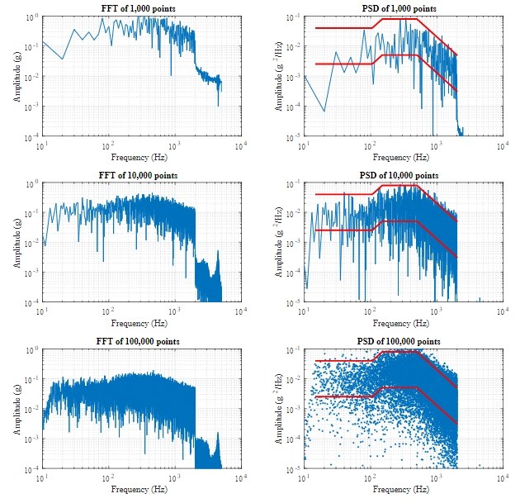

Increasing the number of samples affects how “dense” the spectrums appear, but does not affect the general trends of the vibration data. The normalization enables the comparison of signals of different durations.

A complete example of the analysis procedure can be found below.

1. Obtain time history data points of vibration data at a predetermined sample rate (in discrete time domain)

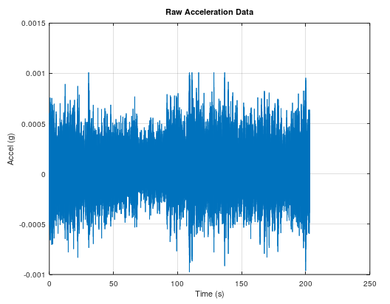

1. Apply fast fourier transform to transform data to frequency domain

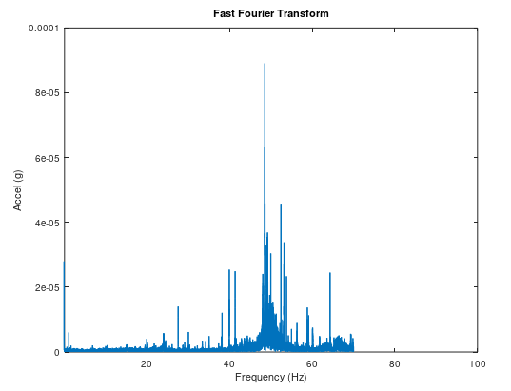

1. Normalize data using acceleration spectral density

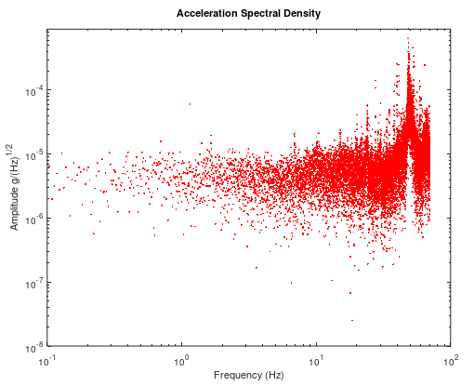

1. Experimental Set-up
2. Hardware

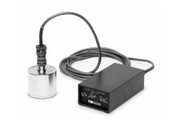

The vibration data is collected using a Wilcoxon 731a Seismic Accelerometer, the corresponding P31 amplifier and acquired via a Labjack T7-Pro Data Acquisition device. The significant specifications of the accelerometer and amplifier are listed below.

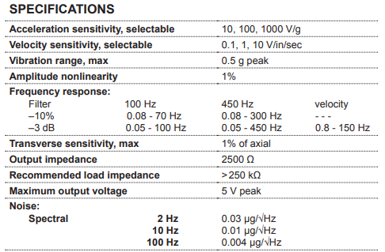

The Labjack T7 Pro has configurable analog inputs depending on the measurement that is recorded. The settings used for the vibration measurements are listed below.

|  |  |
| --- | --- |
| ***Setting*** | ***Configuration*** |
| Channel | AI0 |
| Amplifier Sensitivity | 1000 V/g |
| Analog Input Range | Table: +/- 1V  MinusK: +/- 0.1V |
| Sample Rate | 140 Hz |
| Amplifier BP Filter | 100 Hz |
| Resolution Index | 9 |

The labjack has a 24-bit ADC where the effective resolution changes according to its configuration settings. These specifications are displayed below.

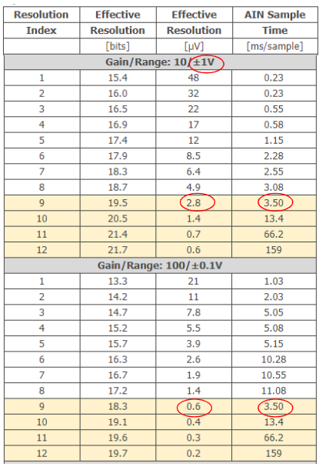

The table above shows the noise limit will be introduced by the Data Acquisition device itself, and has a value of 2.8 microvolts for the +/-1V input configuration and 0.6 microvolt for the +/-0.1V configuration.

1. Troubleshooting to converge on proper settings

The first step for evaluating the MinusK performance was verifying the measurement system functionality. This process consisted of taking measurements with two accelerometers and comparing results, as well as adjusting the seismic accelerometer settings to converge on the optimal configuration listed in the section above.

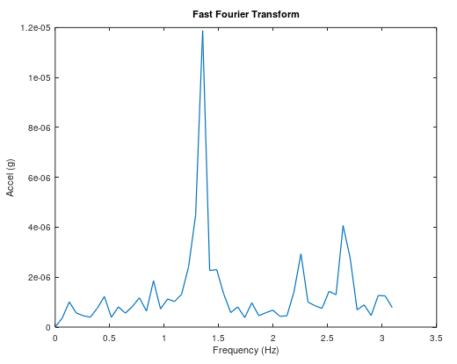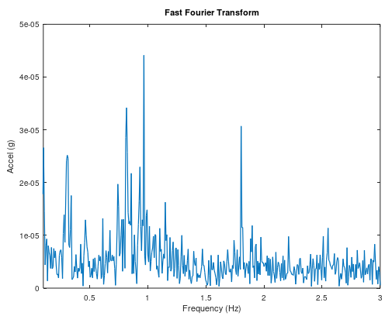

The plots above compare the high resolution (Resolution Index 12 - 6Hz sampling Frequency) results for the ADXL1002 Analog devices Mems accelerometer (left) and the wilcoxon seismic accelerometer (right). The accelerometer data was measuring floor vibration in the office. The major frequencies are all in the same range, meaning the data acquisition system and sensors are generally functioning correctly.

After checking the functionality of the data acquisition system and sensors tests were conducted to determine the optimal settings for the 731a and Labjack. While adjusting filters (100Hz and 450Hz), resolution indexes, analog input connections, and sensitivities it was discovered that the data seemed inconsistent. This was clear from the apparent drift in the raw vibration data. When transformed it manifested as a large peak at 0 Hz.

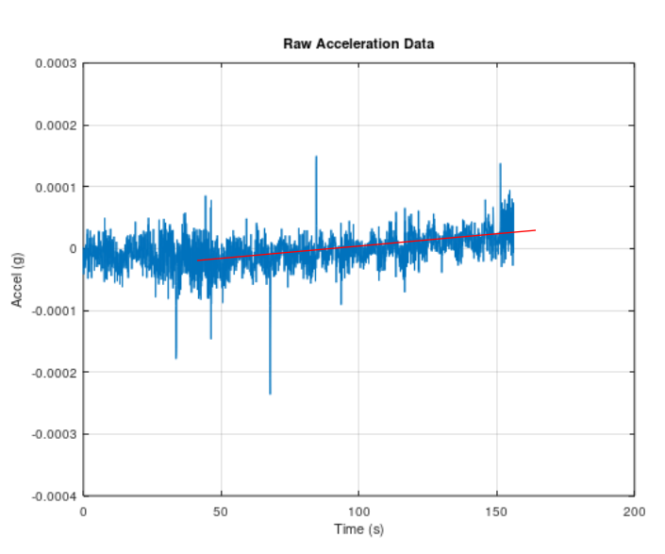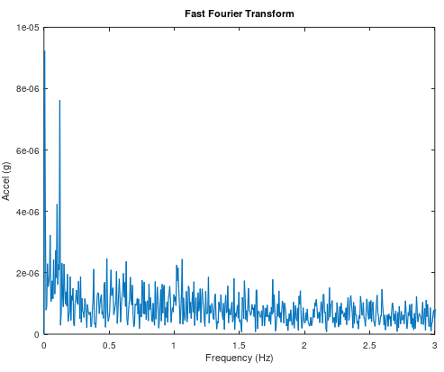

To troubleshoot this issue a data acquisition settings testing matrix, including all adjustable data acquisition and measurement parameters, was organized. A single parameter was adjusted while keeping the remaining variables constant until the problem was replicated. The results of the test can be found below.

|  |  |  |  |  |  |  |
| --- | --- | --- | --- | --- | --- | --- |
| Channel | Resolution  index | Acceleration Sensitivity | Software | Filter | DAQ interface | Channel Configuration Voltage |
| AI0 | 9 | 10 | StreamM | 100Hz | Buffer | 0.01 |
| AI1 | 10 | 100 | LogM | 450Hz | Cable | .1 |
| AI2 | 11 | 1000 |  | Vel |  | 1 |
| AI3 | 12 |  |  |  |  | 10 |

It was discovered the issue was logging the data using Labjack_LogM data logging software instead of Labjack_StreamM software. These programs came with the device so it is unknown how it interacts with the hardware to distort the measurements. After researching the problem online, I suspect that LogM interacts with the hardware in a way that releases too large of a bias current at the measurement channel. This is a problem because of the high impedance of the P31 amplifier.

1. Results
2. MinusK Tests

Initial Tests -

*Non Precision C.G. Location w/ 59 kg*

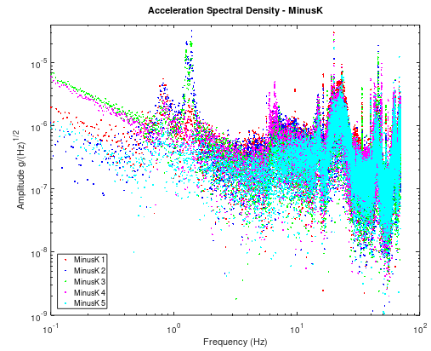

Further Tests -

*Vertical w/ Block*

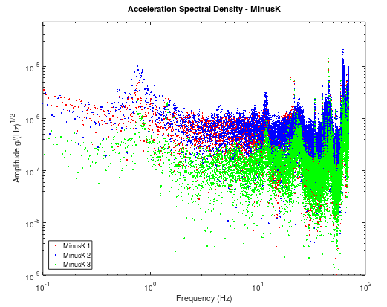

*Horizontal w/ Block*

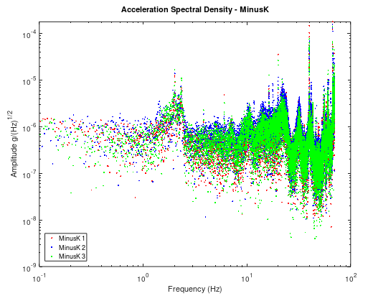

*Precision C.G. Tests*

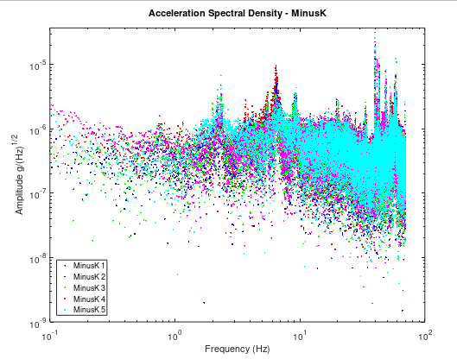

1. Environments Tests

*Mechanical Workbench Vibrations (Vertical)*

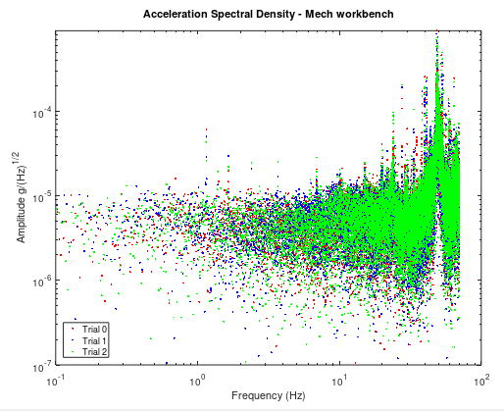

*Optics Lab Table Vibrations (Vertical)*

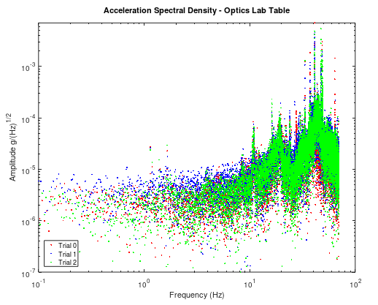

*Vibrations on the Ground @ Site*

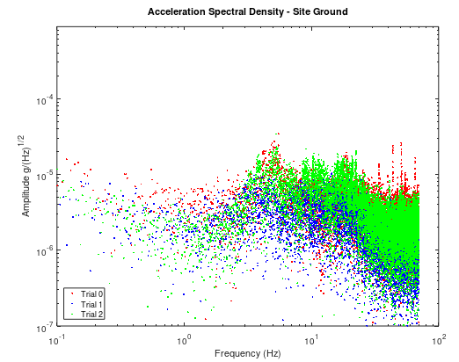

*Vibrations in the BlueSG Car @ Site*

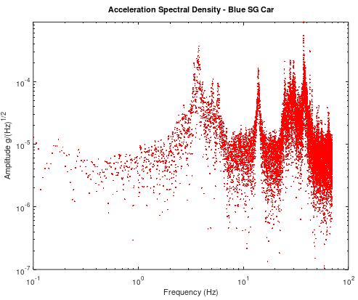

1. Evaluation
2. Comparison of Data
3. *Comparison MinusK vs Workbench (Savitzky-Golay software filter applied)*

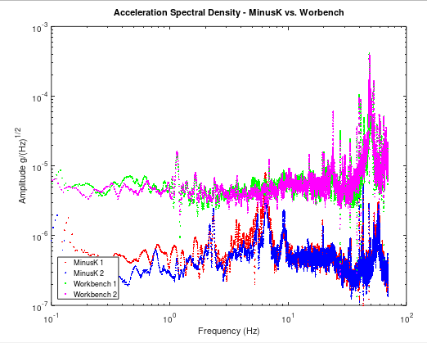

1. *Comparison to Results of Freier*

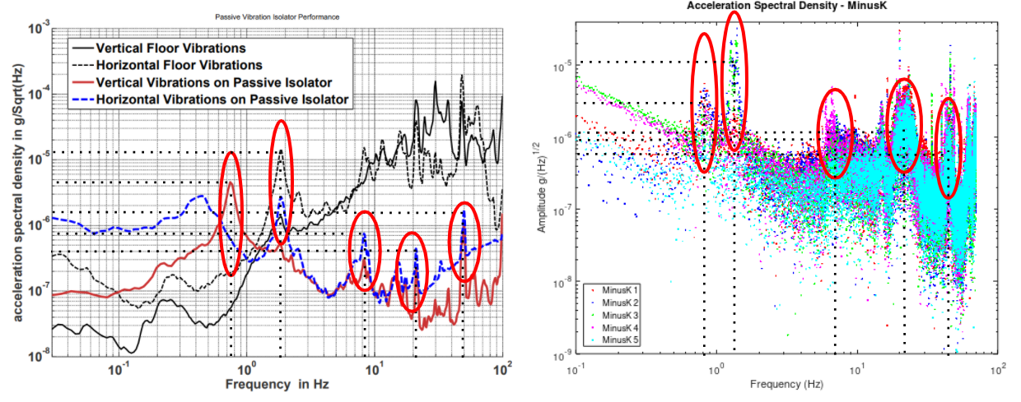

1. *Comparison of Lab Vibrations vs Site (Savitzky-Golay software filter applied)*

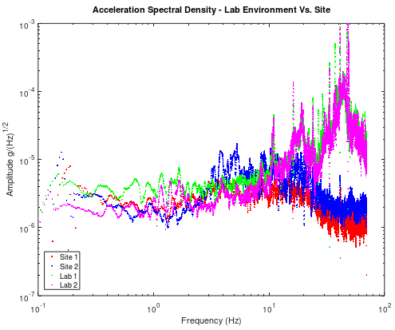

1. *Comparison of the precisely built dummy mass to the initial mass using the dummy mass components (Savitzky-Golay software filter applied)*

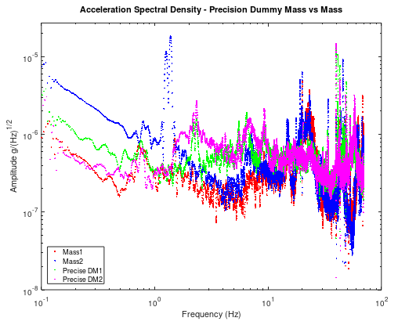

1. Discussion

The purpose of comparing the data sets above is the following:

1. MinusK vs workbench: Display the magnitude of vibration isolation the passive isolator provides. The table represents the input while the output is the MinusK data
2. Results vs Freier: Illustrate that the results are consistent with a PhD student building an identical system
3. Lab environment vs the Site: Show that the lab’s vibratory environment will be more violent than the site of the initial pilot (other than a small frequency band of roughly 3-10Hz). If the passive isolation system is sufficient for the interferometer measurements in the lab, and the vehicle does not drastically amplify the environmental conditions then the instrument should also work at the site
4. Initial Mass on Minus K measurements vs. More precisely built dummy mass: Show that the deviation between the results is small, meaning the geometry of the structure does not matter as much. Will need to confirm this once again in a horizontal configuration.